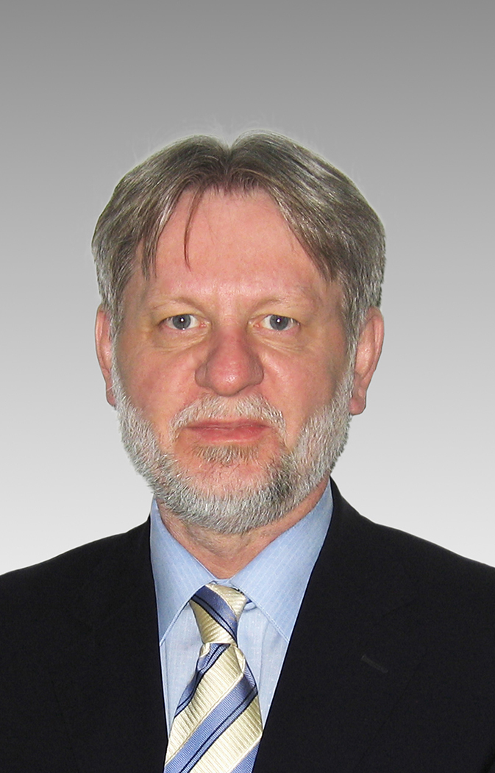

Zeljko Erkapic, MSc.

Zeljko Erkapic is currently holding the position of CEO in Agricultural Equipment Cluster Ltd. This cluster project was initiated within Croatian Employer's Association by founding National Centre for Clusters in the beginning of 2007 which included another 4 cluster initiatives apart from Agricultural Equipment Cluster. Working on that project in structuring and organizing the cluster almost for two and half years, Agricultural Equipment Cluster separated from National Centre for Clusters in July 2009 and formally was registered as Limited Liability Company.
Agricultural Equipment Cluster was awarded with a prize of the Government of the Republic of Croatia and Ministry of Economy, Labour and Entrepreneurship for its achievements, as the most successful cluster in the Republic of Croatia in 2011 and Zeljko was voted for the best cluster manager in Croatia. In 2013 AEC was certified with the „Bronze Label“ certificate of the European Union project „Cluster Excellence“, which additionally ensures greater visibility, recognizability, better positioning and evaluation in further integration regarding the European Union as well as participation in various EU projects and funds.
Before coming to current position, in his career Zeljko worked in several distinguished firms mainly as CEO or commercial manager. His prior education is primarily focused on economics as he graduated the Faculty for Foreign Trade at Zagreb University. He also has a great deal of experience in export and import businesses. During 2004 and after 20 years of experience in the field of economy, he graduated at the postgraduate program of Entrepreneurship at University of J.J. Strossmayer in Osijek and obtained diploma of the Master of Science.
Zeljko is also active in a scientific project “Gaining economic prosperity by strengthening regional competitiveness” started by Faculty of Economics in Osijek. He coauthored several scientific studies at the same faculty. Since summer 2009, Zeljko has actively participated as a lecturer at Public Relations and Media Studies Graduate School “Kairos” in Zagreb teaching introductory program called “Entrepreneurship Basics”.

